Searching
Searching is a core capability upon which much of the system’s functionality is based, and is one of the strongest features of the system, with a wide variety of searching capabilities. Because the ContractManagement^{tm} system provides automatic full text indexing that allows for fast searching through large tables of records for whole words, phrases or strings within a word, searches for a particular contract, or all documents of a certain type, or specific file content within a document can be executed within any table or across all tables in the system. Search features in the ContractManagement^{tm} system include:
- Global Search
- Quick Search
- Advanced Search
- Saved Search
The sections below provide more details on each of these searching features.

Global Search
The Global Search feature is located in the top navigation bar on all main forms performs searches through all system tables at once. By typing in a contract, customer or company name, or some other contract-related content, into the Global Search field, users can find all records in all tables in which some field contains that value. Using the Global Search will produce results that are organized by table and include hyperlinks that take users directly to where the search criteria can be found in each table location throughout the system.
- When searching for number values the system will automatically assume all strictly number values entered are ID values. To search for strictly numeric values outside of ID number include quotation marks around the search requirements. Example: entering 15 will find ID number 15. Entering “15” will find all values of 15 other than ID number 15.
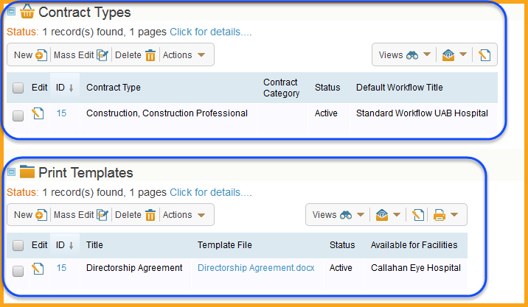

Quick Search
The Quick Search feature allows searches to be completed in an ad hoc manner directly from a table and should be used for non-recurring situations. This search feature allows users to quickly find records or files of interest, and is typically accessed from the Search text/icon found on the toolbar for each table, as well as most subsidiary table forms.
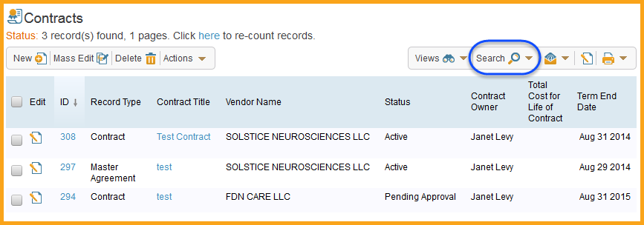

The following is a list of the Search box items and their descriptions:
- Field box – The first input box indicates the field within the table to be searched. If the “-TEXT-“ option is selected, the search will search within all available fields.
- Operator box – The second input box defines the operator of the search. Depending on the field that has been selected to search within, different operators will be available. Numeric or choice fields will provide operators that text fields will not have, such as: “equals, =”, “is greater than or equals, >=”, “and less than, <”, etc.
- Value box – The third input box is where the value to be searched for should be entered.
- Show All checkbox – Selecting this checkbox removes all search criteria to display table records.
- Refine checkbox – Selecting this checkbox narrows an already executed search by allowing new criteria selections to be run against the current search results.
- String checkbox – Selecting this checkbox performs a database search.
- Context checkbox – Selecting this checkbox shows context within search results. This is a very useful option that shows where the specified phrase occurred (including within attached files) so it is easier to locate the desired record.
- Active Only checkbox – Selecting this checkbox narrows the search so that it only displays active records.
- More Options – This link provides string searching and other options.
- Minimize icon () – Selecting this icon in the upper right corner of the Search box removes the Search box from the display.
The Quick Search feature is commonly used to locate contract records that contain specific content (office supplies), companies (FDN Care LLC) or contacts (Janet Levy).
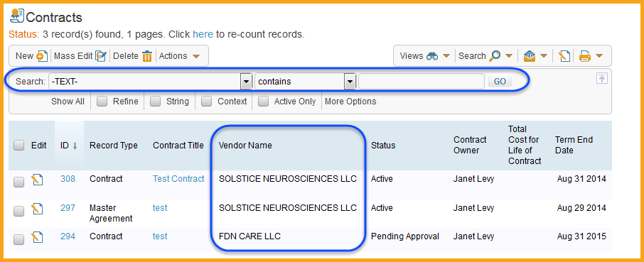

Advanced Search
The Advanced Search feature is used to build complex searches using filters and Boolean expressions. The Advanced Search feature is accessed by selecting New from the Search drop-down menu on the table toolbar.
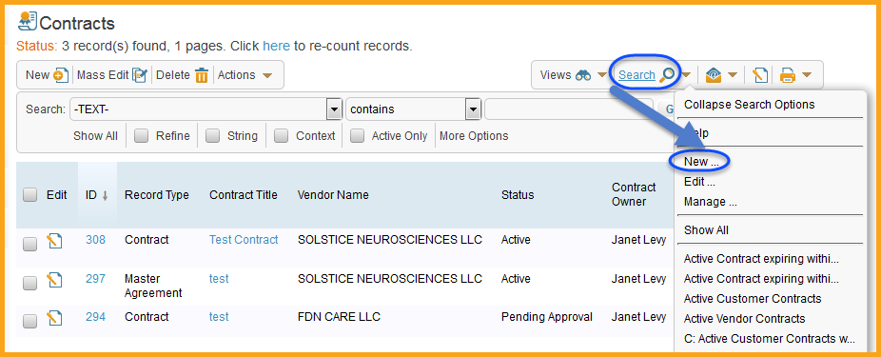
This will display the Search Wizard, which is separated into four tabs. This section will focus on the search criteria options in the General tab. For more information on the other tabs, refer to the Saved Search section below. The following is a list with brief descriptions of the General tab’s search criteria options:
- Simple – This filter is used to find specific field values or to match against other fields or against the user fields of the person running the search.
- Time – This filter is used to search on periods of elapsed time relative to a specific field. The anchor point of a time filter is the field itself.
- Calendar – This filter is often used for reporting. It measures time by calendar periods, such as last calendar month, last calendar week, day, and so on.
- Advanced – This filter is the one that measures change, or the lack of change. This is the basis for much of the system automation.
- Related Table – This filter is used to run searches on linked fields. The filter will only run on an already existing Saved Search in the target table.
- Run-Time – This filter allows for the creation of a complex search while also leaving one variable for the user to complete when the search is run, and is the basis for ContractManagement^{tm} system reports.
- Duplicate – This filter is used to return results on searches that have more than one record fulfilling the criteria.
- First/Last – This filter is used to return either the first or the last result of a search.

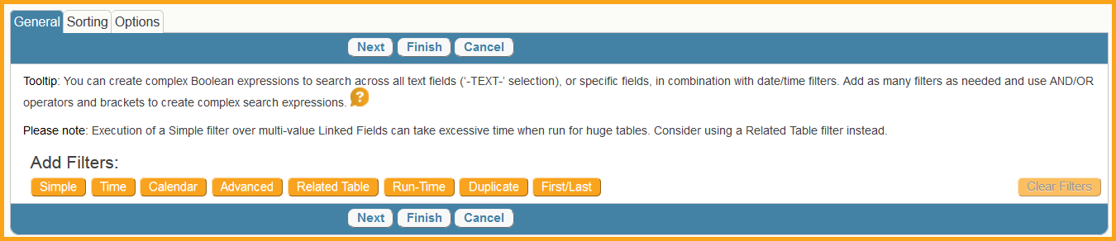
Advanced Search filters provide Boolean expressions and parenthesis options to filter and group complex criteria as needed.
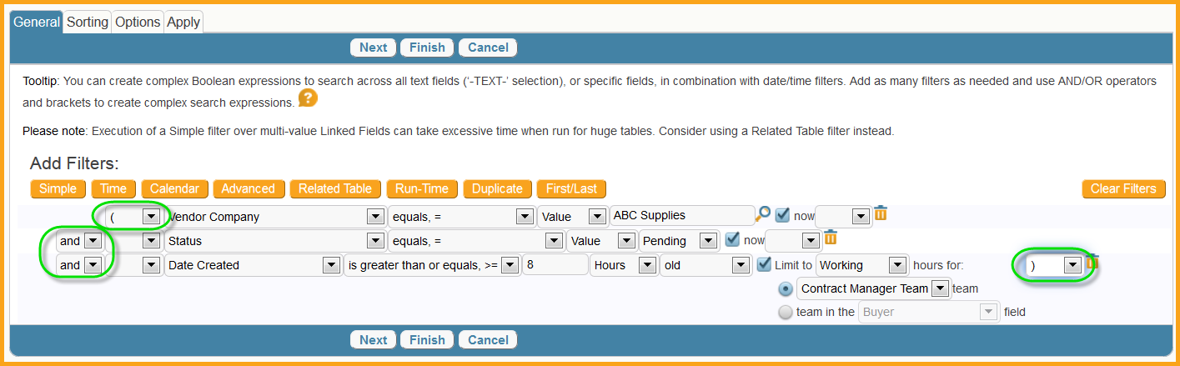
If the selected filter criteria need to be removed for any reason, select the trash can icon next to the criteria row. If all criteria need to be removed, select the Clear Filters button. The Now checkbox restricts the search to look for existing values. If this checkbox is deselected, it will also search the history of the intended records and return results that existed at some point in time.

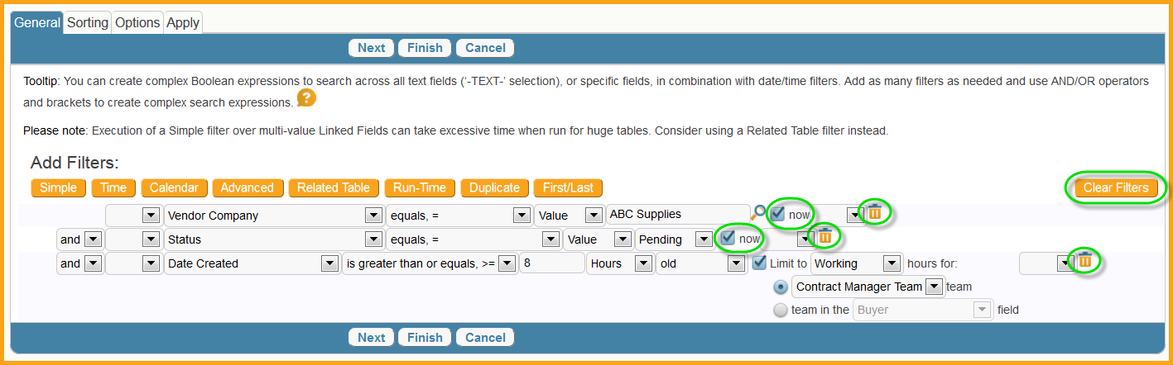

- While the Advanced Search feature is a valuable tool, it does take time and experience to master. It is recommended less-experienced users primarily use the other less complex search features until they have been able to practice and become more familiar with the complexities of the Advanced Search tool.

Saved Search
The Saved Search feature is used to retain and reuse either a simple search, similar to a Quick Search, or a more complex search, similar to an Advanced Search, and some users will have the ability to share their Saved Searches. The Saved Search feature is accessed by selecting New from the Search drop-down menu on the table toolbar.
This will display the Search Wizard, which is separated into four tabs. The following list provides a brief description of each tab, but instructions and more information is included on each tab.
- General tab – This tab is used to define the search criteria. The Simple filter button can be used to create a search similar to a Quick Search. For more information on using the other filter buttons to create a more complex search, refer to the Advanced Search section above.
- Sorting tab – This tab allows users to define how the search results are displayed based on the best match and add up to five fields.
- Options tab – This tab allows users to name search, as well as choose table restrictions, searching of sub-tables, include synonyms and other search display options.
- Apply tab – This tab provides for the definition of which users the search is accessible to and active for, and where it will be displayed. This tab is only available to administrators.
A Saved Search will appear on the Search menu.

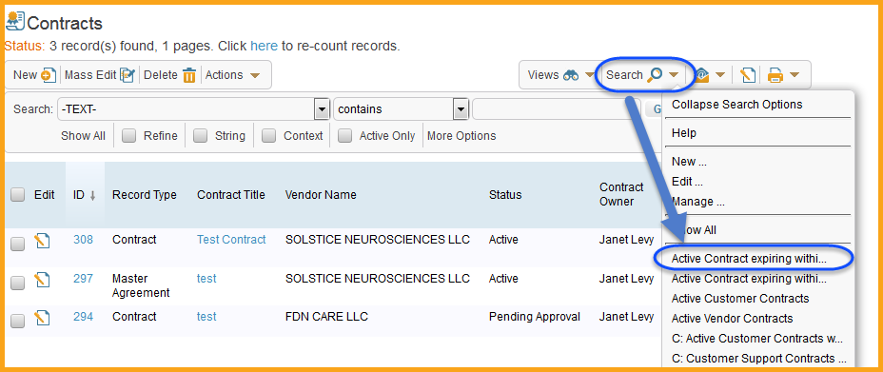

Exercises
The following exercises are related to using the various search features of the ContractManagement^{tm} system.

Create a Global Search
The purpose of this exercise is to practice executing a search across all tables of the ContractManagement^{tm} system. For more information on using the Global Search feature, refer to the Global Search section above.
- In the Global Search field located on the top navigation bar, enter a company name and select the Go button.

- In the results that appear in the right functional pane, select the ID link or edit icon() of each item that appears under each table heading to see the items that contain the word entered into the Global Search field. This exercise is complete.
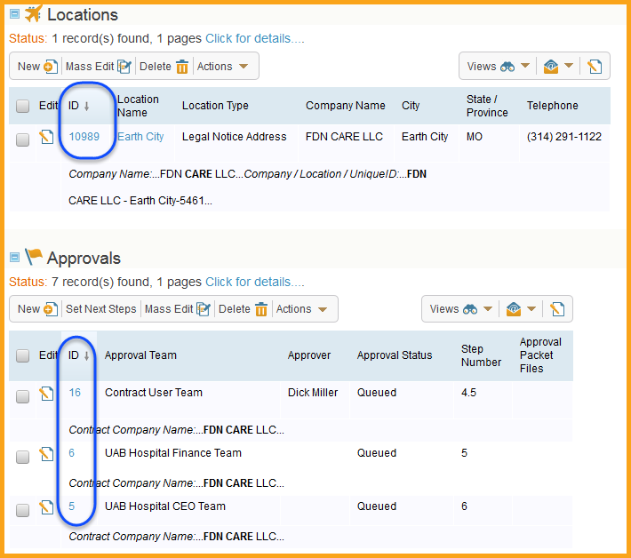

Create a Quick Search
The purpose of this exercise is to practice executing a fast, simple search against a table in the ContractManagement^{tm} system. For more information on using the Quick Search feature, refer to the Quick Search section above.
- Select the Contracts table from the tables list in the left navigation pane.
- Select the Search text/icon on the table toolbar.
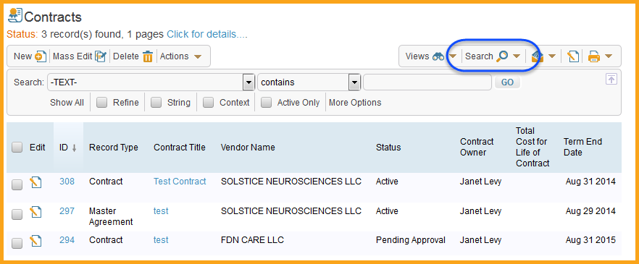

- In the Search box that appears, select “Contract Owner” or another person field from the drop-down list in the first box, which is the Field selection box.
- In the second box, which is the Operator selection box, select the “equals, =” item.
- In the third box, which is the Value box, enter a name of an employee, then select the Go button.
- The search results will appear in the area below the Search box to reflect all contract records that contain the search criteria entered.
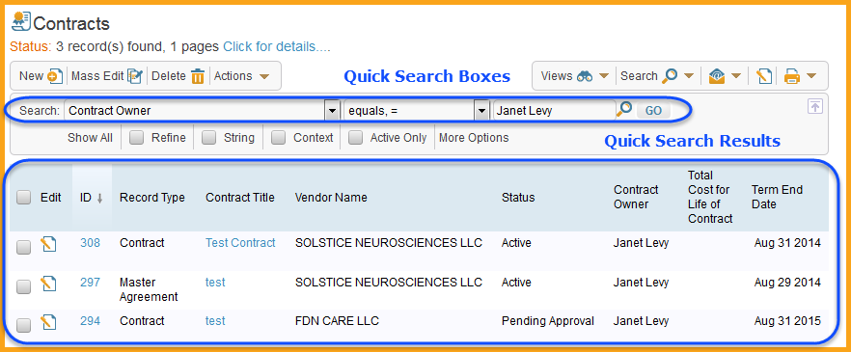

- Refine the search results to narrow them down to only list records where the external party name is a vendor in the instance by first selecting the Refine checkbox in the Search box. This will maintain the original search criteria.
- Change the Field box selection to the vendor name field the Operator box selection to “equals, =” and the Value box to the vendor in question, then select the Go button.
- This will result in fewer result items listed based on the refined criteria.
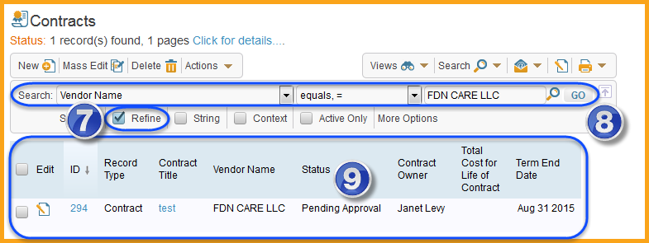

- To clear all search criteria and return to the normal list of table records, select the Show All link. This exercise is complete.

Create an Advanced Search
The purpose of this exercise is to practice executing a complex search against a table in the ContractManagement^{tm} system. For more information on using the Advanced Search feature, refer to the Advanced Search section above.
- Select the Contracts table from the tables list in the left navigation pane.
- From the Search text/icon drop-down menu on the table toolbar, select New.
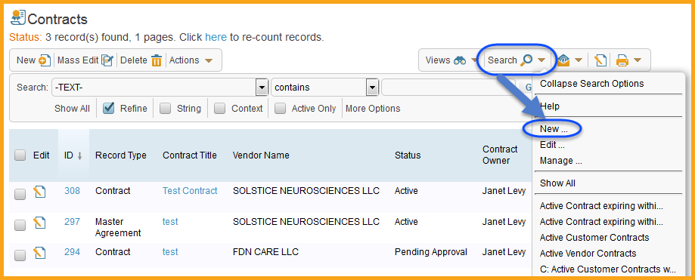

- The New button will open the Search Wizard in a new window. There are a number of types and options for building a complex search. In this example, the search will be setup to only find the first contract record where the vendor field contains a word of the users choice and the record was created in the current month.
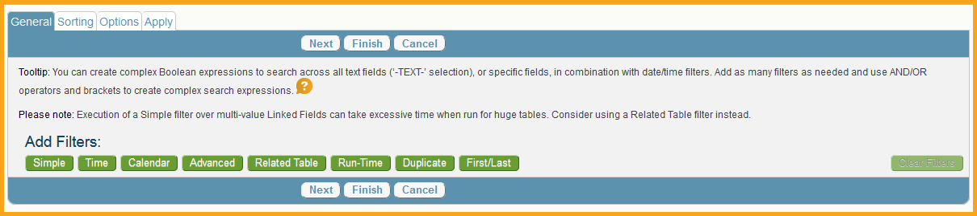

- In the Search Wizard’s General tab, select the Simple button. The Simple button will add a row of boxes in the General tab to enter search criteria similar to that of a Quick Search.
- Select the vendor field option in the Field selection box.
- Select the “contains” item from the Operator selection box.
- Enter the vendor name into the Value selection box.
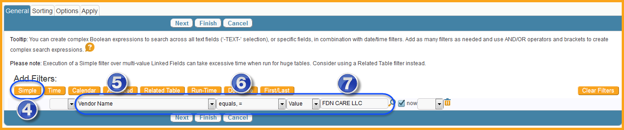
- Now select the Calendar button, which will add another row below the Simple row.
- Select “Date Created” in the Field selection box.
- Select the “is equal to” item in the first Operator selection box.
- Select the “this” in the second Operator selection box.
- Select “Month” in the Value selection box.
- Select the Finish button.
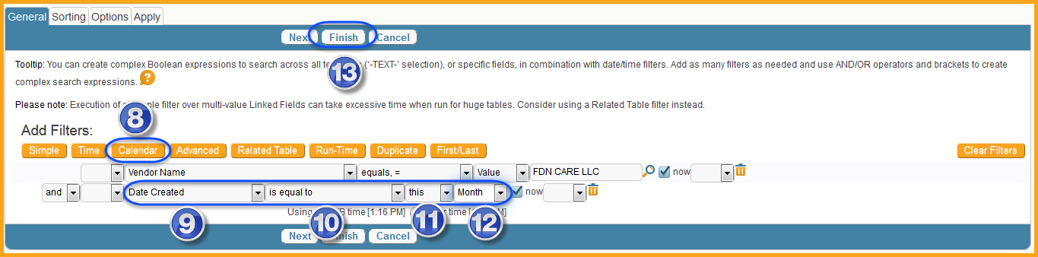

- Since this search only needs to be run once and not be saved, select the Run without Saving button in the Confirm pop-up window. For more information saving searches, refer to the Saved Search section above.
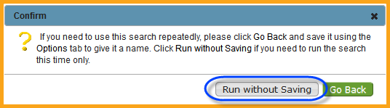

- The search results will display in the right functional pane. This exercise is complete.
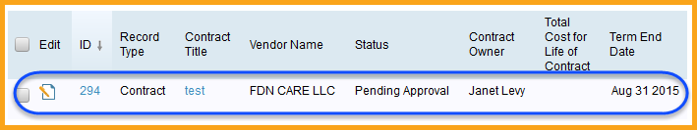

Create a Saved Search
The purpose of this exercise is to practice creating a search against a table that can be reused in the ContractManagement^{tm} system. For more information on using the Saved Search feature, refer to the Saved Search section above.
- Select the Contracts table from the tables list in the left navigation pane.
- From the Search text/icon drop-down menu on the table toolbar, select New.

- The New button will open the Search Wizard in a new window. There are a number of types and options for building a search. In this example, the search will be a simple search setup to only find contract records where the Contract Buyer is equal to the user’s name. For more information setting up complex search, refer to the Advanced Search section above.

- In the Search Wizard’s General tab, select the Simple button. The Simple button will add a row of boxes in the General tab to enter search criteria similar to that of a Quick Search.
- Select the “Contract Owner” option in the Field selection box.
Note: If the user is not a Contract Owner, select another option that matches the users position such as “Contract Requester”.
- Select the “equals, =” item from the Operator selection box.
- Enter the users name into the Value selection box. This should result in the system trying to match this value to the existing employee record name.
- Select the Next button.
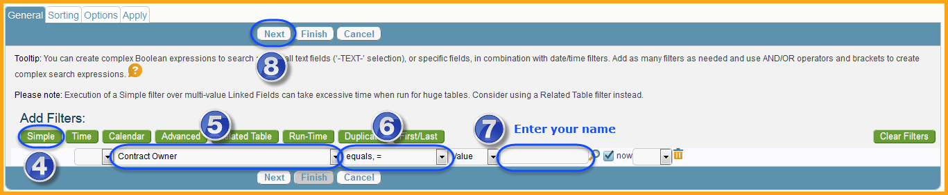

- On the Sorting tab, leave the default First Sort box checked and the “ID” value, but change the order to “Ascending”.
- Select the Next button.
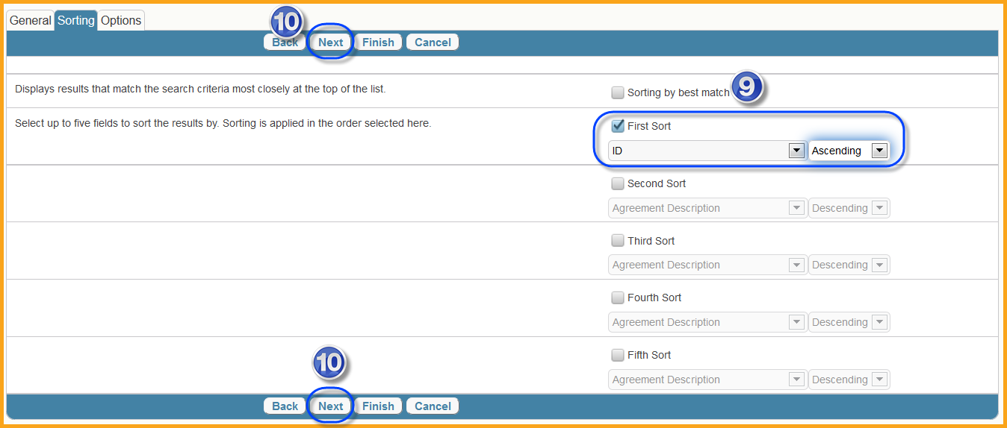

- On the Options tab, select Yes under Save Search.
- Enter “[user’s name] Contracts” in the Name field, which will automatically update the Label field.
- Enter the desired description for the search in the Description field.
- Select the Save as new Saved Search checkbox.
- Leave all other fields with their default values and select the Finish button.
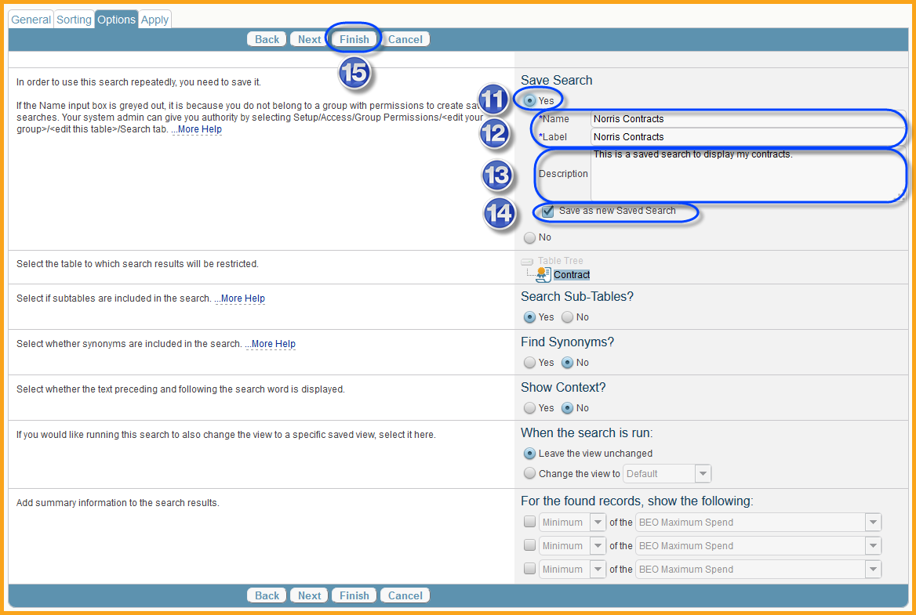

- The search results will display in the right functional pane, and the new Saved Search will appear as an option on the Search menu. This exercise is complete.
