Mass Edit

Mass editing allows users to select multiple records within a table and perform any edits to fields within these records in a single action. This option is useful when a single field needs to be updated to a new default value across all records.

To mass edit records select the records that needs to be edited on the left side check box. Additionally, all records on a page or all records in a table can be selected with the mass selection box in the column header area. Once the records that will be edited are selected click the Mass Edit button in the Action Bar.

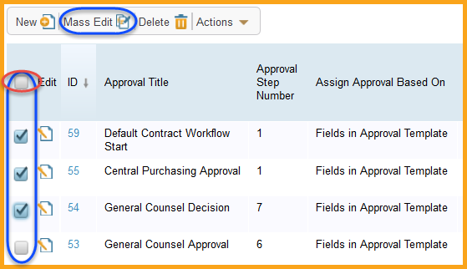

The mass edit wizard will then ask which fields in these records need to be updated. Select the check box to the left of every field that needs to be updated and click Next.

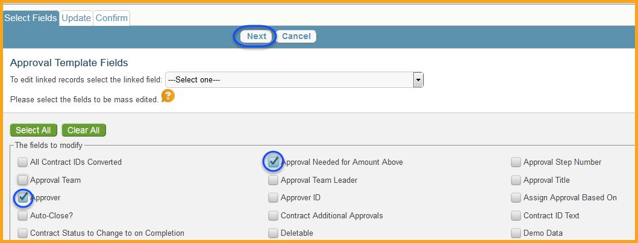

The Update tab will then allow users to enter new information for each field. The new information can be Standard Text, allowing for free text results to be entered, or A Formula, allowing for complex formulas to be entered or system variables to be referenced. Depending on the field type will determine the options for Standard Text (choice fields will only show the choices available, date fields will only allow dates, etc.).

While very uncommon additional options for changes can be used, such as pre-established searches, team information replaces, or other options depending on the field type selected. Once the new value is entered click the Next option to move to the Confirm tab.

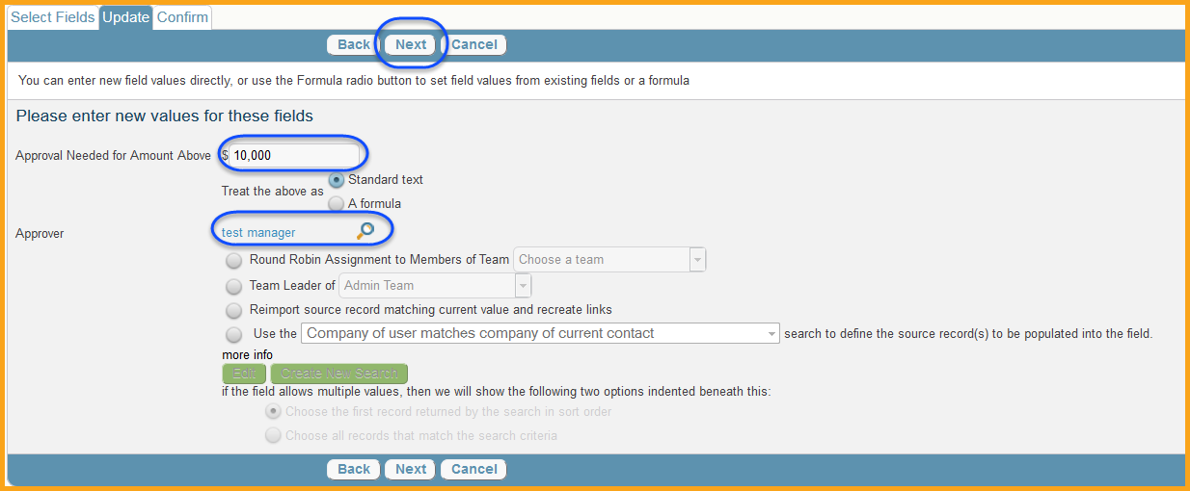

While Formulas can be used in various areas of the system, they are most commonly associated with field updates. When selecting “A Formula” during a mass edit for example, a new action button is available titles Formula Help. It is always advisable to use the Formula Help button when attempting to make updates using a formula.

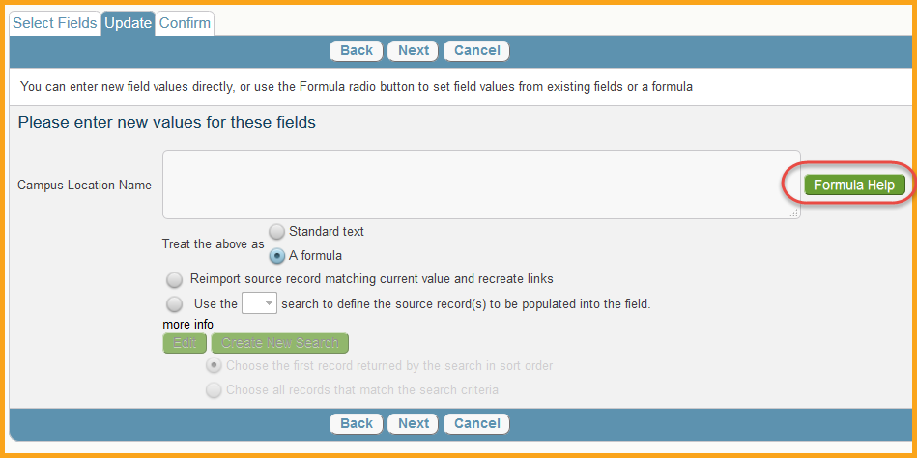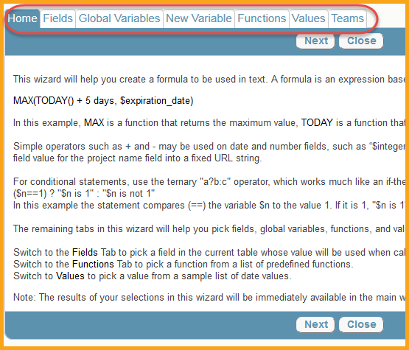

The Formula Help Wizard will provide several useful tabs to help users determine the appropriate formula for their update. The most commonly used tab is the Fields tab, which will allow users to update a value in a field, with the values found in a different field automatically. Global Variables is another helpful tab that will allow users to update a field with a predetermined global system variable value. These include things such as “My Full Name”, which will enter the dynamic value of whoever is logged it. Global Variables are always dynamic and will be reflective of who/when/which value is being entered. New Variables should generally be avoided. Functions correspond to mathematical values, such as Sum. These can allow for field updates to be done based on the dynamic values of multiple fields, utilizing mathematical formulation. The Values tab is useful in measuring the difference between values in terms of time. For example, a date field can be updated to “Contract End Date minus 30 days”, where the value of 30 is determined based on which value is selected. Finally, the Teams tab can update a team based field with a list of available team. It may take some time before fully getting the hang of updating values based on formulas; however the feature is extremely useful and can save significant time in making many updates in a single action.

The confirm tab will allow users to confirm the changes they are making, and will provide the option to list all IDs that have been updated after the update occurs. Click Finish to update the records.

