Searching
After logging into the ContractManagement^{tm} system Portal interface, the Search Toolbar from the Home tab will be available for use. The Search Toolbar will provide users to search within the Contracts table or perform a generic Google search, but choosing the appropriate radio button.
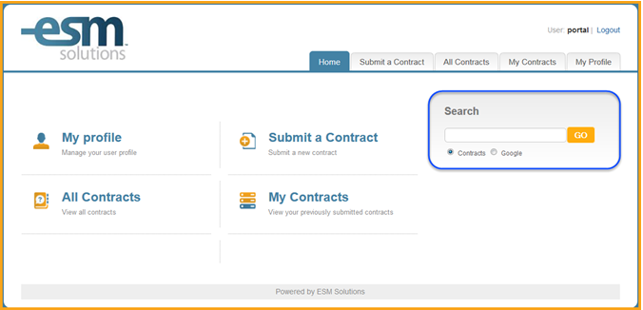

Google Searches

Choosing the Google radio button will allow users to enter words or phrases in the search bar, which will utilize the Google search engine. Searches performed this way will create a new pop-up window, with the search results populated. After entering the search phrase, select the GO button to execute the search. The new window can be closed at any time, which will not close the ContractManagement system window, allowing users to search as needed, using Google.

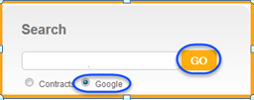

Contract Searches

Searching within the Contracts table will allow users to find all contracts they are part of, either as a requester, approver, or part of a team associated with the contract record. They will also be able to find all contracts that are made public to the users facility. To perform this search, enter the searched phrase in the search box, and select the Contracts radio button, then select GO. The search toolbar will attempt to auto-fill the selection field with phrases it recognizes, or were previously searched on.

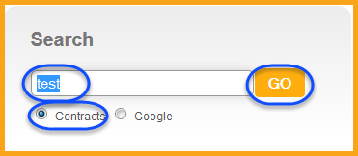

The system will then refresh showing all results it was able to find.

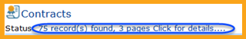

Saved Searches
Upon executing a search, the system will direct the user to the All Contracts tab. Additionally, this tab can be selected from the home page directly.

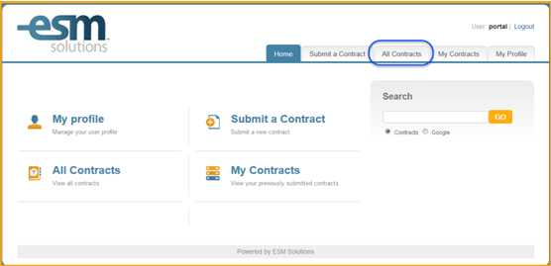

Once the All Contracts tab is selected any available Saved Searches will be available for use, as well as the ability to perform a new search.

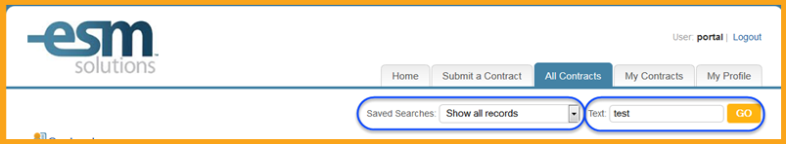

Use the drop down in the Saved Searches field to see all saved searches a user has access to. Saved Searches will allow users to quickly search for records based on a predefined set of filters, matching the requirements the user has requested. If a new saved search will be required, contact the facilities System Admin to request a new search be built and made available. By default Show All Records will be selected.

