DocuSign Process

The signature process for DocuSign begins with an email automatically generated from the DocuSign webpage once an envelope has been submitted. Contract Managers within the environments will create, assign, and submit DocuSign envelopes to both internal and external parties. The email request to sign a document within DocuSign will be sent from the DocuSign email address. To begin the process select the View Documents button within the email.

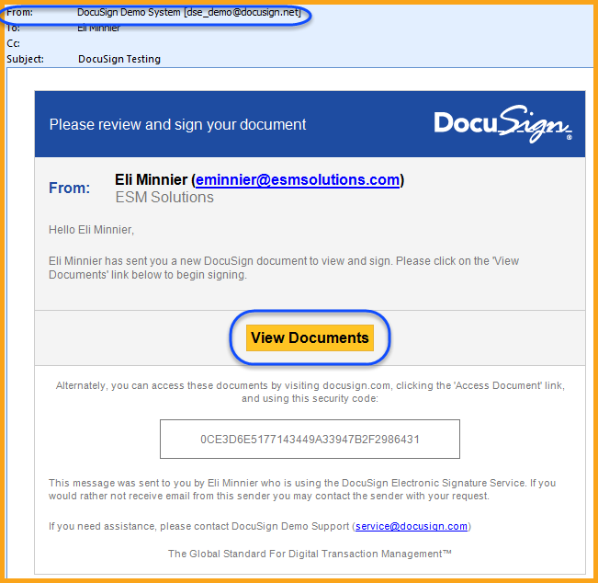

Upon signing into DocuSign the first time each user will be asked some basic information to complete their user profile. This typically includes your full name, title, and company. Depending on how the DocuSign envelope is set up, some of this information can automatically be entered for you from the ContractManagement system. You will only have to enter this information once and DocuSign will remember it, based on your email address for all future signature requests.

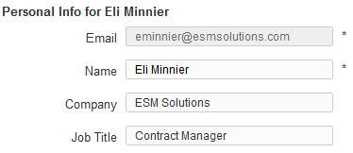

Signing a Document

Once the basic user profile has been complete, each user will be presented with options on how to complete the signature request. The Request for Signature option within DocuSign will allow each user to:
- Review Document – Complete the signature process within DocuSign, allowing the user to review the request and automatically assign their signature to the document.
- Finish Later – Postpone signing the document until a later time.
- Sign on Paper – Allow each user to print, sign, and fax the wet-ink signed document back to DocuSign.
- Change Signer – Delegate the signing of this document to a different user. This will require the user to enter a reason for delegation, the new user’s name, and the new users email address. All changes will be recorded in the system and automatically updated.

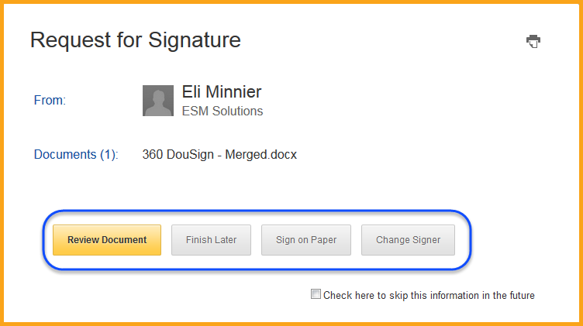

In most cases the Review Document selection will be used. Upon selecting this option, DocuSign will show each user the document they are signing, allowing each user to fully review the request. DocuSign provides several options to allow the users to quickly navigate within the document request:

- The top navigation bar – Allows quick page up and page down, view sizing, document downloading and printing.
- Right page navigation bar – Allows quickly jumping to a specified page.
- Next button – Will automatically direct the user to the next section that requires their signature. Selecting this button will move the user to the signature page, directly into the section they need to sign.

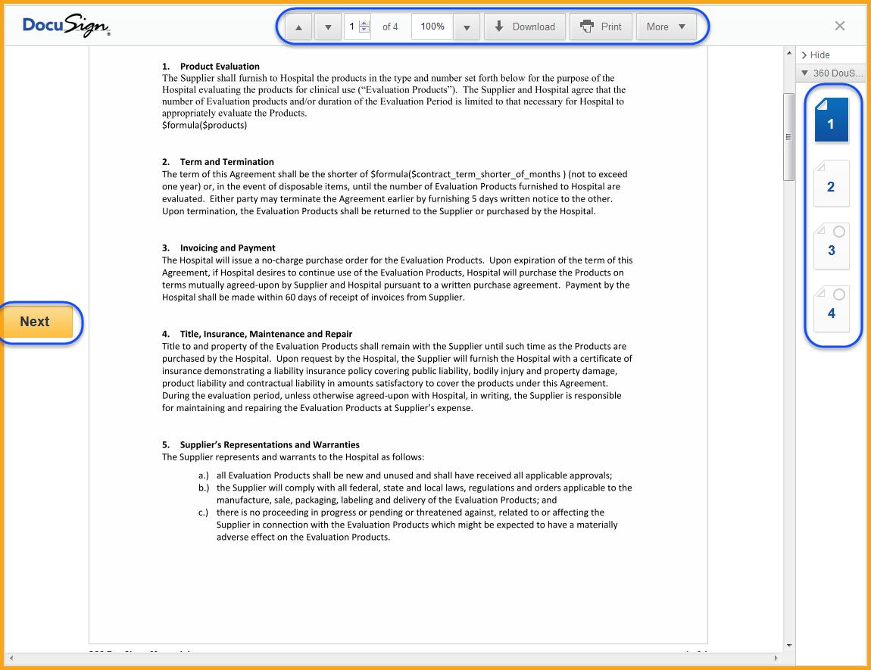

Selecting the Next button or scrolling to the signature requirement page will prompt each user to enter their DocuSign signature with the Sign Here button. The Next button will be changed to the Sign button as well. Selecting Sign Here will add the user’s signature to the document, based on their first and last name.

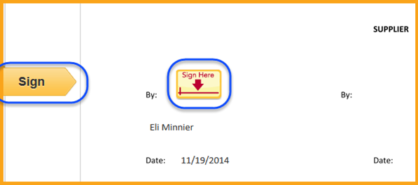

If more than 1 signature is required the Sign button will update to the Next button, allowing the user to move to the next signature they need to enter. Once all signatures are completed, DocuSign will display the user’s signature and the Sign button will automatically update to the Confirm Signing button.

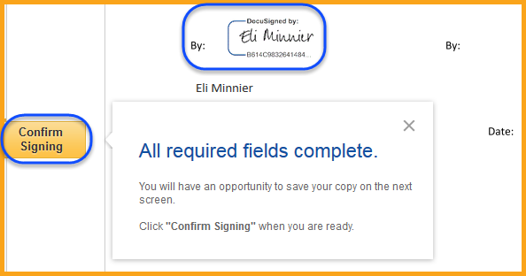

Selecting the Confirm Signing button will complete the DocuSign request. If the user has more than 1 pending signature request DocuSign will ask them if they want to move to the next signature request.

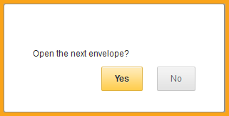

If no more pending signature requests are available simply close the DocuSign webpage and the process is complete.

