# Basic Navigation

The purpose of this section is to provide detailed information and practice exercises related to logging into the ContractManagementtm system, as well as navigating the various tools and displays available.

## Logging In

### Web Browsers

The ContractManagementtm system must be accessed via a web browser. The following are the supported browser types that can be used to access the system:

* Firefox *(preferred)*
* Internet Explorer
* Chrome
* Safari

Because browser versions are constantly changing, the ContractManagementtm system is typically certified to work with the browser’s current full release version, as well as one full release version back. It is important to note that the ContractManagementtm system, like so many other web-based applications, does not work well with Internet Explorer 8. Thus, it is recommended to only use Internet Explorer 9 or higher. The preferred browser choice for the system is Firefox.

It is also recommended to only use navigational tools found within the ContractManagementtm system, rather than the browser navigational tools.

### Browser Pop-ups

The ContractManagementtm system requires the browser being used to be configured to allow pop-ups. Pop-up settings are different for each browser type and they can periodically be changed and relocated.

Browser add-ons, like the Google toolbar, may also block pop-ups and will need to be configured to allow pop-ups for the ContractManagementtm system.

### Web Address

After opening a web browser, navigate to the login page by entering the system URL.

* *The Training and Production environments are accessed via different URLs.*

If you have any questions about or experience accessing the login page, please contact the system administrator.

### Username & Password

On the Login page, enter your Username and Password. If you cannot remember your password, select the “Forgot your password?” link next to reset your password. To reset your password, provide your username or email address, so that an email message can be sent with the new password and instructions. If you cannot remember your username or experience any issues with or have questions about your username and password, contact the system administrator.

A successful login will result in the three primary display areas, which include the name of the person logged in the main navigation bar at the top, the main system tabs in the left navigation pane and the Contract Manager Home Page dashboard in the right functional pane. More information on these display areas is provided in the next section.

## System Overview

The ContractManagementtm system has the following primary display areas:

1. Top navigation bar
2. Left navigation pane
3. Right functional pane

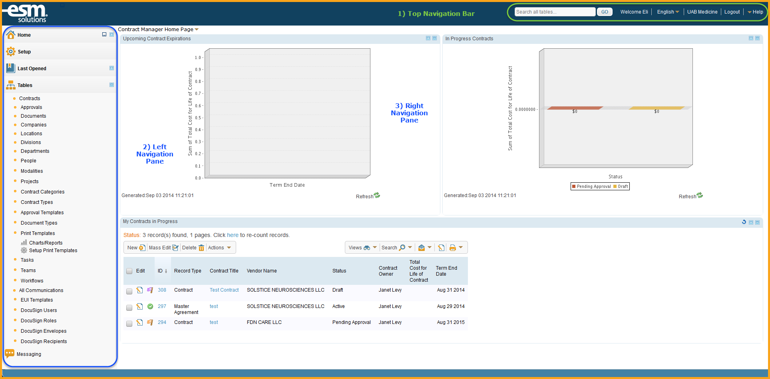

* *Each of these areas has specific tools and functionality that is made accessible to users based on assigned permissions.*

### Top Navigation Bar

The top navigation bar provides the following features:

1. A Global Search
2. A Welcome message that includes the user’s first name
3. A language control option
4. The institution’s name
5. A Logout link
6. A Help menu

### Left Navigation Pane

The left pane provides access to all tables and most functions available to a user and contains the following tabs:

1. The Home tab, which contains a user’s dashboards, summary and combined reports, profile information and preference settings.
2. The Last Opened tab, which shows the last 5 opened items, and is used for fast access to recently viewed records.
3. The Tables tab, which displays all tables that a user has permissions to access.

### Right Functional Pane

The right pane provides access to the full display view of each table or tool selected in the left pane. The first time a user logins, the default view in the right functional pane will be the Contract Manager Home Page dashboard. Users are able to change this default dashboard view to another existing dashboard or create new dashboards to view.

## Top Navigation Bar

The top navigation bar contains a number of items, but is currently limited in functionality and usefulness. The following sections provide additional information about some of these features.

### Global Search

The Global Search tool performs simultaneous searches through all system tables, such as searching for all documents, companies, and contact records that contain a specific person’s name or other textual content.

### Language Options

The language control option is currently set to only display information in English.

### Help Options

The Help menu currently provides information about the entire platform the ContractManagementtm system is built on, but does not contain details specific to the individual instance.

* *This feature cannot currently be disabled, so it is recommended that users disregard this information. For help information specific to your instance such as system documentation, training and support resources, users should refer to materials provide by the ESM Solutions Support Library website.*

### Logout

When all necessary work has been completed in the ContractManagementtm system, users are required to logout of the system using the provided Logout link in the top navigational toolbar. It is also recommended that the browser be closed after logging out.

* *The system automatically logs a user out after 120 minutes of inactivity, but provides a 20 minute warning.*

More information on the content and features available from the left navigational and right functional panes is provided in later sections of this document.

# 